HOME PAGE CODE 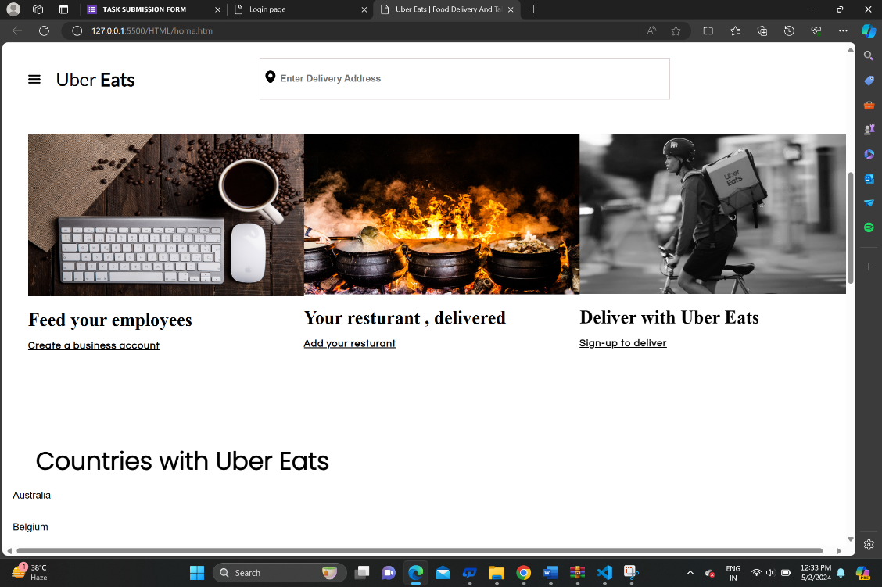

<!DOCTYPE html>

<html lang="en">

<head>

    <meta charset="UTF-8">

    <meta http-equiv="X-UA-Compatible" content="IE=edge">

    <meta name="viewport" content="width=device-width, initial-scale=1.0">

    <title>Uber Eats | Food Delivery And Takeout | Order Online From ubereats.com</title>

    <link rel="stylesheet" href="../CSS/nav_bar_style.css">

    <link rel="stylesheet" href="../CSS/below_navbar_styles.css">

    <link rel="stylesheet" href="../CSS/mid_box_styling.css">

    <link rel="stylesheet" href="../CSS/countries_list_styling.css">

    <link rel="preconnect" href="https://fonts.googleapis.com">

    <link rel="preconnect" href="https://fonts.gstatic.com" crossorigin>

    <link href="https://fonts.googleapis.com/css2?family=Lato&display=swap" rel="stylesheet">

    <link rel="preconnect" href="https://fonts.googleapis.com">

    <link rel="preconnect" href="https://fonts.gstatic.com" crossorigin>

    <link href="https://fonts.googleapis.com/css2?family=Roboto&display=swap" rel="stylesheet">

    <link rel="preconnect" href="https://fonts.googleapis.com">

    <link rel="preconnect" href="https://fonts.gstatic.com" crossorigin>

    <link href="https://fonts.googleapis.com/css2?family=Questrial&display=swap" rel="stylesheet">

    <link rel="preconnect" href="https://fonts.googleapis.com">

    <link rel="preconnect" href="https://fonts.gstatic.com" crossorigin>

    <link href="https://fonts.googleapis.com/css2?family=Poppins:wght@300&display=swap" rel="stylesheet">

    <link rel="preconnect" href="https://fonts.googleapis.com">

    <link rel="preconnect" href="https://fonts.gstatic.com" crossorigin>

    <link href="https://fonts.googleapis.com/css2?family=Lato:wght@300&display=swap" rel="stylesheet">

</head>

<body>

    <div id="container">

        <div id="nav_bar">

            <div id="left">

                <img src="../PICS/nav_logo.svg" width="20px" alt="" id="logo">

                <h3 id="uber_title"> <span id="uber">Uber</span><span id='bolder'> Eats</span></h3>

            </div>

            <div class="mid">

                <img src="../PICS/location.svg" alt="" width="20px" id="nav_location_logo"><input type="search" name=""

                    id="nav_searchbar" placeholder="Enter Delivery Address">

            </div>

            <div id="right">

                <div id="login"><button> <img src="../PICS/user.svg" alt="" id="user_logo" width="20vh"><span

                            id="log_text">Log in</span></button></div>

                <div id="signup"><button>Sign up</button></div>

            </div>

        </div>

        <div id="below_navbar">

            <div><span id="phrase">Order food to your door</span></div>

            <div id="search_area">

                <img src="../PICS/location.svg" alt="" width="20px" id="location_logo"> <input type="search" name=""

                    id="address" placeholder="Enter Delivery Address">

                <select name="Delivery" id="delivery">

                    <option class="opt">Deliver Now</option>

                    <option class="opt">Schedule For Later</option>

                </select>

                <button id="Find">Find Food</button>

            </div>

        </div>

    </div>

    <div id="mid_boxes">

        <div id="b1">

            <img src="../PICS/image1.jpg" width="450px" height="264.5px" alt="">

            <h2>Feed your employees</h2>

            <h4><u>Create a business account</u></h4>

        </div>

        <div id="b2"> <img src="../PICS/image2.jpg" width="450px" height="261px" alt="">

            <h2>Your resturant , delivered</h2>

            <h4><u>Add your resturant</u></h4>

        </div>

        <div id="b3"><img src="../PICS/image3.png" width="450px" height="260.5px" alt="">

            <h2>Deliver with Uber Eats</h2>

            <h4><u>Sign-up to deliver</u></h4>

        </div>

    </div>

    <h1 id="cont">Countries with Uber Eats</h1>

    <div id="countries">

        <div id="b1">

            <li>Australia</li>

            <li>Belgium</li>

            <li>Canada</li>

            <li>Chile</li>

            <li>Costa Rica</li>

            <li>Domanican Republic</li>

            <li>Ecaudor</li>

            <li>El Slavadr</li>

        </div>

        <div id="b1">

            <li>Australia</li>

            <li>Belgium</li>

            <li>Canada</li>

            <li>Chile</li>

            <li>Costa Rica</li>

            <li>Domanican Republic</li>

            <li>Ecaudor</li>

            <li>El Slavadr</li>

        </div>

        <div id="b1">

            <li>Australia</li>

            <li>Belgium</li>

            <li>Canada</li>

            <li>Chile</li>

            <li>Costa Rica</li>

            <li>Domanican Republic</li>

            <li>Ecaudor</li>

            <li>El Slavadr</li>

        </div>

        <div id="b1">

            <li>Australia</li>

            <li>Belgium</li>

            <li>Canada</li>

            <li>Chile</li>

        </div>

    </div>

    <hr id="line">

    <div id="footer">

        <div id="leftfoot">

            <div>

                <h2 id="footer_head"><span id="light">Uber</span> <span id="boldt">Eats</span></h2>

            </div>

            <div id="download">

                <img src="../PICS/appstore.svg" alt="">

                <img src="../PICS/play.png" alt="" width="136px">

            </div>

        </div>

        <div id="rightfoot">

            <div id="lst1">

                <li>Get Help</li>

                <li>Buy Gift Cards</li>

                <li>Add your resturant</li>

                <li>Sign-up to deliver</li>

                <li>Create a business account</li>

                <li>Promotions</li>

            </div>

            <div id="lst2">

                <li>Resturants near me</li>

                <li>View cities</li>

                <li>View all coutries</li>

                <li>Pick up near me</li>

                <li>About Uber Eats</li>

                <li>Promotions</li>

            </div>

        </div>

    </div>

    <hr id="line">

</body>

<script type="module" src="../LOGICS/logic1.js"></script>

<script type="module" src="../LOGICS/functions.js"></script>

<script src="../LOGICS/login_page_logics.js"></script>

</html>

LOGIN PAGE 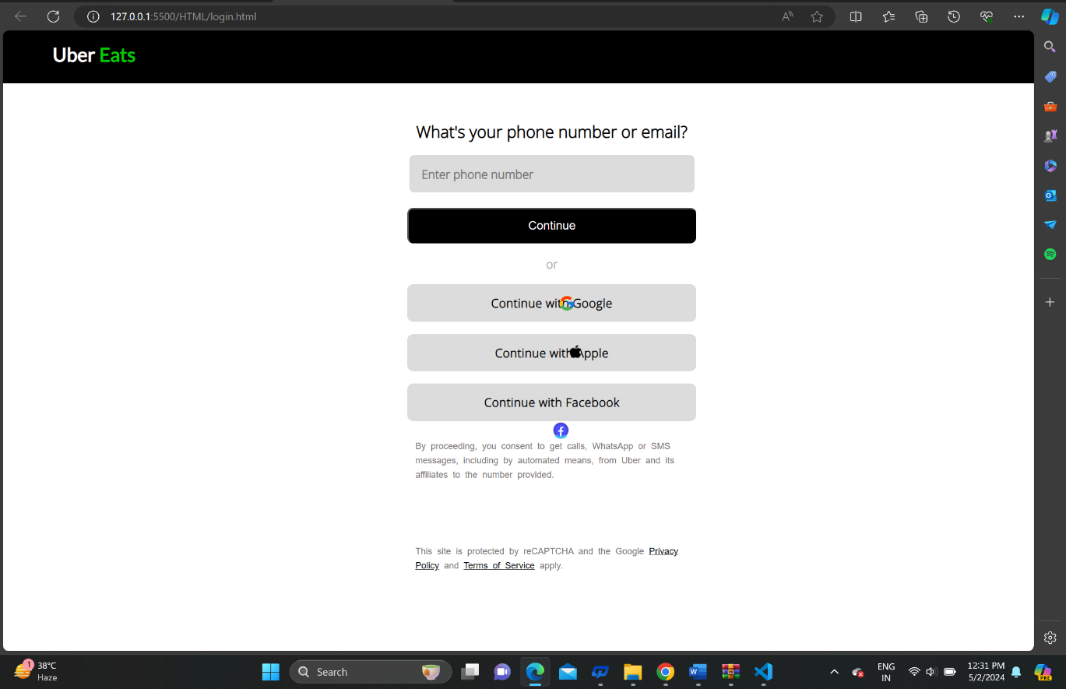

<!DOCTYPE html>

<html lang="en">

<head>

    <meta charset="UTF-8">

    <meta http-equiv="X-UA-Compatible" content="IE=edge">

    <meta name="viewport" content="width=device-width, initial-scale=1.0">

    <title>Login page</title>

    <link rel="stylesheet" href="../CSS/login_page_designs.css">

    <link rel="preconnect" href="https://fonts.googleapis.com">

    <link rel="preconnect" href="https://fonts.gstatic.com" crossorigin>

    <link href="https://fonts.googleapis.com/css2?family=Open+Sans:wght@300&display=swap" rel="stylesheet">

    <link rel="preconnect" href="https://fonts.googleapis.com">

    <link rel="preconnect" href="https://fonts.gstatic.com" crossorigin>

    <link href="https://fonts.googleapis.com/css2?family=Lato&display=swap" rel="stylesheet">

</head>

<body>

    <div id="nav">

        <div id="left">

            <h1>Uber <span id="eats">Eats</span></h1>

        </div>

    </div>

    <!-- login box starts here -->

    <div id="login_box">

        <div id="login_head">

            <h1>What's your phone number or email?</h1>

        </div>

        <div><input type="text" name="" id="mail_box" placeholder="Enter phone number"></div>

        <div id="error_msg">Please enter a valid phone or email</div>

        <button id="btn">Continue</button>

        <div id="or">

            <p>or</p>

        </div>

        <div id="google"><button class="buttons">

                <img src="../PICS/google.png" alt="" id="google_logo"> Continue with Google

            </button></div>

        <div id="apple"><button class="buttons">

                <img src="../PICS/apple.png" alt="" id="apple_logo">

                Continue with Apple

            </button></div>

        <div id="Facebook"><button class="buttons">

                <img src="../PICS/fb.png" alt="" id="fb_logo">

                Continue with Facebook

            </button></div>

        <div id="warning">

            <p>By proceeding, you consent to get calls, WhatsApp or SMS messages, including by automated means, from

                Uber and its affiliates to the number provided.

            </p>

        </div>

        <div id="footer">

            This site is protected by reCAPTCHA and the Google <u class="link">Privacy Policy</u> and <u

                class="link">Terms of Service</u> apply.

        </div>

    </div>

</body>

<script src="../LOGICS/login_page_logics.js"></script>

</html>

NAVBAR STYLE 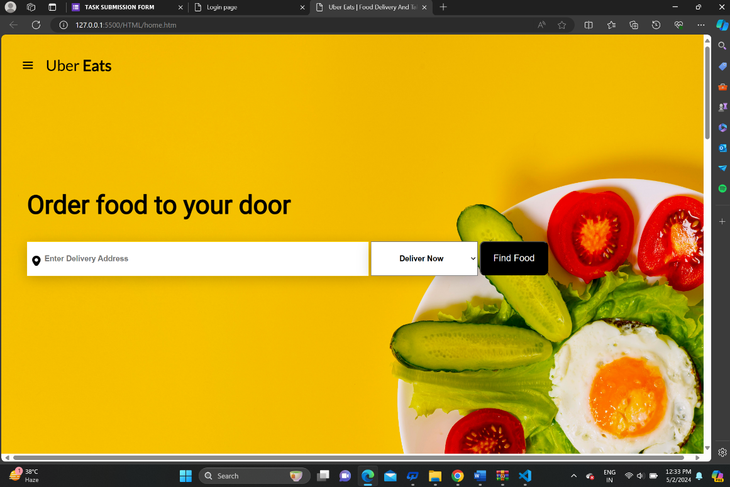

#below_navbar {

    position: absolute;

    margin-left: 6vh;

    margin-top: 19rem;

}

#phrase {

    font-size: 50px;

    font-family: 'Roboto', sans-serif;

    font-weight: bolder;

    letter-spacing: .0001ch;

}

#address {

    box-shadow: 0 5px 25px rgba(0, 0, 0, 0.2);

    width: 80vh;

    height: 2vh;

    margin-top: 5vh;

    font-size: 15px;

    font-weight: bold;

    padding: 4vh;

    border: 1px solid rgb(255, 213, 0);

}

#location_logo {

    position: absolute;

    top: 15.5vh;

    left: 1vh;

}

#delivery {

    width: 25vh;

    font-size: 15px;

    font-weight: bold;

    height: 8vh;

    box-shadow: 0 5px 25px rgba(0, 0, 0, 0.2);

    cursor: pointer;

}

.opt {

    width: 25vh;

    font-size: 15px;

    font-weight: bold;

    height: 8vh;

    text-align: center;

}

#Find {

    width: 16vh;

    height: 8vh;

    background-color: black;

    color: white;

    font-size: 18px;

    border-radius: 10px;

    cursor: pointer ;

}

#Find:hover{

    filter:opacity(70%);

    transition-duration: .1s;

}

COUNTRY LIST STYLING

a#countries {

    margin-left: 5vh;

    margin-top: 1vh;

    display: flex;

    justify-content: space-between;

}

#cont {

    font-size: 40px;

    margin-left: 6.5vh;

    margin-top: 10vh;

    font-family: 'Poppins', sans-serif;

    font-weight: bolder;

}

#countries #b1 li {

    list-style: none;

    padding: 2vh;

    font-weight: lighter;

    font-family: Arial, Helvetica, sans-serif;

}

#line {

    margin-top: 3vh;

    border-top: rgb(31, 29, 29);

}

#footer {

    display: flex;

    width: 100%;

    margin-top: 10vh;

}

#rightfoot {

    margin-left: 80vh;

    display: flex;

    /* width: 50vh; */

}

#footer_head {

    font-family: 'Lato', sans-serif;

    font-size: 2rem;

}

#boldt {

    font-weight: bolder;

}

#light {

    font-weight: lighter;

}

#rightfoot li {

    list-style: none;

    padding: 1.5vh;

    font-family: 'Lato', sans-serif;

    cursor: pointer;

}

#rightfoot li:hover {

    text-decoration: underline;

}

#leftfoot {

    margin-left: 5vh;

    display: flex;

    flex-direction: column;

    /* width: 40vh; */

}

#download {

    margin-top: 15vh;

}

#lst2 {

    margin-left: 15vh;

}

LOGIN PAGE DESINGS

* {

    margin: 0;

    padding: 0;

}

#nav {

    background-color: black;

    height: 8.5vh;

    color: white;

}

#left {

    display: inline-block;

    margin-top: 2vh;

    margin-left: 8vh;

    font-size: 13px;

    font-family: 'Lato', sans-serif;

    font-weight: lighter;

    letter-spacing: .002ch;

}

#eats {

    color: rgb(5, 203, 5);

}

#login_box {

    display: flex;

    flex-direction: column;

    justify-content: center;

    width: 44vh;

    align-items: center;

    margin-left: 40%;

    margin-top: 6vh;

}

#login_head {

    font-size: 11px;

    font-family: 'Open Sans', sans-serif;

    font-weight: bolder;

}

#mail_box {

    width: 42vh;

    padding: 2vh;

    height: 2vh;

    font-size: 16px;

    border-radius: 7px;

    border: white;

    background-color: gainsboro;

    margin-top: 2vh;

    font-family: 'Open Sans', sans-serif;

    font-weight: bolder;

}

#error_msg {

    /* position: absolute; */

    margin-left: -14vh;

    margin-top: 2vh;

    color: red;

    font-family: 'Open Sans', sans-serif;

    font-size: 14px;

    font-weight: bolder;

    display: none;

}

#btn {

    width: 46.5vh;

    padding: 1.5vh;

    font-size: 16px;

    background: #000;

    color: white;

    margin-top: 2.5vh;

    border-radius: 8px;

}

#btn:hover {

    cursor: pointer;

    filter: opacity(85%);

    transition-duration: .2s;

}

#or {

    margin-top: 2vh;

    color: rgb(181, 176, 176);

    font-weight: bolder;

    font-family: 'Open Sans', sans-serif;

}

.buttons {

    width: 46.5vh;

    padding: 1.5vh;

    font-size: 16px;

    background: gainsboro;

    margin-top: 2vh;

    border-radius: 8px;

    border: white;

    height: 6vh;

    cursor: pointer;

    font-family: 'Open Sans', sans-serif;

    font-weight: bolder;

    letter-spacing: .05ch;

}

.buttons:hover {

    background: rgba(0, 0, 0, .19);

    transition-duration: .2s;

}

#google_logo {

    position: absolute;

    width: 23px;

    left: 89.5vh;

}

#apple_logo {

    position: absolute;

    width: 21px;

    left: 91vh;

}

#fb_logo {

    position: absolute;

    width: 32px;

    left: 88vh;

    top: 62.5vh;

}

#warning,

#footer {

    font-size: 12px;

    font-weight: lighter;

    font-family: Arial, Helvetica, sans-serif;

    color: rgb(122, 118, 118);

    margin-top: 3vh;

    word-spacing: .5ch;

    line-height: 2.9ch;

}

#footer {

    margin-top: 10vh;

}

.link {

    cursor: pointer;

    color: black;

}

MID BOX STYLING

#mid_boxes {

    display: flex;

    justify-content: space-between;

    width: 95%;

    height: 50vh;

    margin-left: 5vh;

    margin-top: 10vh;

}

#b1,#b2,#b3 {

    cursor: pointer;

}

#b1 h2,

#b2 h2,

#b3 h2 {

    margin-top: 2vh;

    margin-bottom: 2vh;

    font-size: 30px;

}

#b1 h4,

#b2 h4,

#b3 h4 {

    font-family: 'Questrial', sans-serif;

    font-weight: light;

    letter-spacing: .11ch;

}

NAV BAR STYLE

* {

    margin: 0;

    padding: 0;

}

#container {

    width: 100%;

    height: 110vh;

    background-image: url(../PICS/page_bg.jpg);

    background-size: cover;

}

#nav_bar {

    height: 13vh;

    font-family: 'Lato', sans-serif;

    /* position: fixed;

    top: 0;

    width: 100%; */

    z-index: 9999999;

}

#left {

    display: flex;

    padding: 2vh;

}

#logo {

    margin-left: 3vh;

    margin-top: 3vh;

}

#uber {

    font-weight: 500

}

#bolder {

    font-weight: 900;

}

#logo {

    cursor: pointer;

}

#uber_title {

    margin-left: 3vh;

    margin-top: 3vh;

    font-size: 30px;

}

#right {

    display: flex;

    position: relative;

    left: 166vh;

    top: -10vh;

}

#login button,

#signup button {

    width: 14vh;

    height: 7vh;

    border-radius: 25px;

    font-size: 15px;

    font-weight: bold;

    margin: 2vh;

    cursor: pointer;

}

#login button {

    background: white;

    color: black;

}

#signup button {

    background: black;

    color: white;

}

#user_logo {

    position: absolute;

    left: 4.3vh;

}

#log_text {

    position: relative;

    right: -1.5vh;

}

#signup button:hover {

    filter: opacity(70%);

    transition-duration: .1s;

}

.mid {

    position: absolute;

    left: 50vh;

    top: -2vh;

    display: none;

}

#nav_searchbar {

    width: 80vh;

    height: 2vh;

    margin-top: 5vh;

    font-size: 15px;

    font-weight: bold;

    padding: 4vh;

    border: 1px solid rgb(218, 204, 204);

}

#nav_location_logo {

    position: absolute;

    top: 7.5vh;

    left: 1vh;

}

JS FUNTION

    export function grayeffect() {

    let b1 = document.getElementById('b1')

    let b2 = document.getElementById('b2')

    let b3 = document.getElementById('b3')

    b1.addEventListener('mouseover', function () {

        b1.style.filter = 'grayscale(100%)'

    })

    b1.addEventListener('mouseout', function () {

        b1.style.filter = 'grayscale(0)'

    })

    b2.addEventListener('mouseover', function () {

        b2.style.filter = 'grayscale(100%)'

    })

    b2.addEventListener('mouseout', function () {

        b2.style.filter = 'grayscale(0)'

    })

    b3.addEventListener('mouseover', function () {

        b3.style.filter = 'grayscale(100%)'

    })

    b3.addEventListener('mouseout', function () {

        b3.style.filter = 'grayscale(0)'

    })

}

JS LOGIC

import { grayeffect } from "./functions.js"

let nav = document.getElementById('nav_bar')

let mid = document.getElementsByClassName('mid')[0] 

let login_btn = document.getElementById('login')

let signup_btn = document.getElementById('signup')

window.addEventListener('scroll', function () {

    if (pageYOffset > 0) {

        nav.style.backgroundColor = 'white'

        nav.style.transitionDuration = '.3s'

        nav.style.position = 'fixed'

        nav.style.width = '100%'

        nav.style.top = "0";

    }

    else {

        nav.style.backgroundColor = ""

        nav.style.height = '13vh';

    }

})

window.addEventListener('scroll', function () {

    if (pageYOffset > 300) {

        mid.style.display = "inline"

    }

    else {

        mid.style.display = "none"

    }

})

grayeffect()

login_btn.addEventListener('click', function () {

    window.open('login.html')

})

signup_btn.addEventListener('click', function () {

    window.open('login.html')

})

JS LOGIN PAGE

let inp = document.getElementById('mail_box')

let errormsg = document.getElementById('error_msg')

let btn = document.getElementById('btn')

btn.addEventListener('click', function () {

    let a=inp.value

    if (inp.value.length < 10)

        errormsg.style.display = 'inline'

    else if (isNaN(a))

        errormsg.style.display = 'inline'

    else

        errormsg.style.display = 'none'

})